Hello Ulysses,

In this issue:
Sidewalk update
Public Hearing on Inn at Taughannock
Fascism discussion
Rabies clinic
Tree removal
Election updates
Farmer’s Market seeks board members
Village of Tburg updates
Tompkins County updates
NYS updates
Upcoming town meetings
Community Calendar

TOWN OF ULYSSES NEWS:
Sidewalk project update
The sidewalk project has started along the Smith Woods side of Route 96 between ShurSave and Falls Rd. This project is in funded by federal dollars and is in conjunction with the Village of Trumansburg. Sidewalks will be also be installed along South Street and also part of Lake Street.

In a separately funded project, the sidewalk in front of Town Hall is also being replaced in order to better delineate the pedestrian way and to add more green space to the area. Because it is a bit torn up out there, it’s best to use the parking lot and entrance in the back of the building.
Check out the rendering below of what the new streetscape and sidewalk may look like:

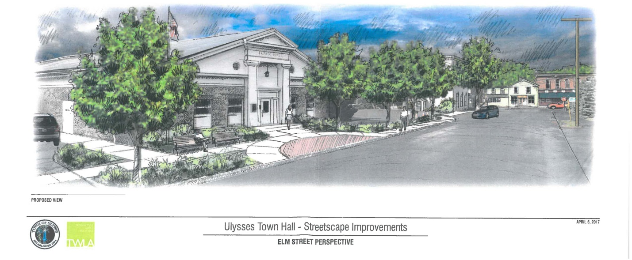

Public Hearing
On October 3, 2017 at 7:05 PM in the Ulysses Town Hall, 10 Elm St, Trumansburg, NY, the Town of Ulysses Planning Board will hold a public hearing to consider site plan approval for the Inn at Taughannock site development for a level lawn with gardens and patios. The project includes the construction of retaining walls, stone fence walls, grading/filling, reconfiguration of the patio/stairway on the south side of the Inn, landscaping and a stormwater system. The property is located at 2030 Gorge Rd, Tax Parcel Number 14.-1-11, B1-Business District. TFI LANDCO, LLC, owner; Carl Mazzocone, contact for owner; Jason Demarest, architect.

The above application is open to inspection at the Zoning Office, Town of Ulysses. Persons wishing to appear at such hearing may do so in person or by other representative. Communications in writing in relation thereto may be filed with the Zoning Office at Kiley@ulysses.ny.us or at the following address:
Town of Ulysses Zoning Office, 10 Elm St, Trumansburg, NY 14886

FROM ORGANIZATIONS AFFILIATED WITH THE TOWN OF ULYSSES:
What is Fascism?
Wed. Oct. 4. 6-8pm at the Ulysses Town Hall
Tom Butler from Lifelong will talk on this topic. Mr. Butler graduated from Yale in 1971 and has taught for 40 years, specializing in history and economics. The fee for the lecture is $10. To register, contact Lifelong at 273-1511.

FREE Rabies Vaccination Clinics
A free rabies clinic will be held in Trumansburg at the School Bus Garage, 100 Whig St., on Thursday, Oct 5, from 7-9pm. On-line pre-registration is available to save time at https://apps.health.ny.gov/doh2/applinks/cdmspr/
For information or to see locations of other clinics, visit http://www.tompkinscountyny.gov/health/eh/neighborhood/rabies#clinics

OTHER HAPPENINGS AROUND TOWN:
Tree removal on Route 96 near fairgrounds
NYSEG and the New York State Department of Transportation, in cooperation with the Trumansburg Fair Association (a private entity), have removed hazardous trees from both Trumansburg Fair Association property and in the New York State right-of-way.

A few local residents, with the help of the Town of Ulysses, have applied for a grant that includes an inventory of the remaining trees. This will help establish a baseline for a tree management plan that can be proposed to the Trumansburg Fair Association.

ELECTION NEWS:
Election calendar dates:
- Oct 13 - Last day to register in person or by mail for the 2017 General Election. Form must be postmarked by 10/13 and received by 10/18
- Oct 13 - Last day for County Board of Elections to receive/accept Change of Enrollment applications.
- Oct 31 - Last day to postmark Absentee Application for the November 7 General Election.
- Nov 6 - Last day to postmark Absentee Ballot for November 7 General Election.
- Nov 7- General Election
For more information, visit the Tompkins County Board of Elections website at http://tompkinscountyny.gov/boe.
VILLAGE OF TRUMANSBURG NEWS:
From the Trumansburg Farmer’s Market Board:
Trumansburg Farmers Market call for board members! We are a small board consisting of both vendors and community members interested in maintaining and growing our vibrant Farmers Market. We meet once per month, currently first Mondays from 6-7pm. Please send just a few sentences about your interest, relevant background, and any questions you may have to Kathi at kscp10@gmail.com. Thank you!

Sign up for new electronic newsletter
The Village of Trumansburg now has an electronic newsletter. Sign up here:
http://trumansburg-ny.us16.list-manage.com/subscribe?u=7e7c83e6425e965b62c3416ee&id=ae86fb2149

TOMPKINS COUNTY NEWS:
Members sought for environmental boards
The County is accepting applications for two volunteer citizen boards that advise the County Legislature on decisions made about our local environment:
- Water Resources Council (WRC)- Meetings are held at the TCAT Transit Center on the third Monday of each month at 4:15 PM (subject to rescheduling if a conflict occurs with holidays).
- Environmental Management Council (EMC)- Meetings are held the second Thursday of each month at 4:00 PM, at the Old Jail, 125 E. Court Street in downtown Ithaca.

Tompkins County residents are invited to submit an application no later than Friday, October 6, 2017. Municipal representatives on the Environmental Management Council must also submit a resolution of support from the municipality.

Interviews will be conducted by subcommittees of the EMC and WRC, and appointments will be made by the Tompkins County Legislature. For an application, visit the County’s website at http://www.tompkinscountyny.gov/legislature/advisory-board, or call the Legislature office at 607-274-5434.

Community Budget Forum- October 2nd
The Tompkins County Legislature will hold its annual Community Budget Forum on Monday, October 2, beginning at 7:00 p.m.

The public information meeting on the budget will be held at County Legislature Chambers, located on the second floor of the Governor Daniel D. Tompkins Building, 121 E. Court Street, Ithaca

County residents are invited to attend to learn about the 2018 recommended County budget presented by County Administrator Joe Mareane and to discuss their opinions with legislators. The forum invites public comments before the committee considers any recommended changes to the Administrator’s budget; those voting sessions begin October 10th.

The Recommended Budget supports total expenditures of $179 million (an increase of 1.6%) and local dollar spending of $86.6 million (an increase of 1.0%), meets the Legislature’s 2018 budget goal of a 2.4% increase in the County property tax levy, and is well below the County’s projected 3.53% tax cap. The property tax rate will go down again in 2018, to $6.58 per $1,000—a reduction of 0.7%. Under the Recommended Budget, the County property tax bill for the owner of a median-valued $178,000 home would increase by $12.

The 2018 Recommended Budget, with schedules and other budget-related information, is posted on the budget page of the County web site at www.TompkinsCountyNY.gov/ctyadmin/2018budget.

Paper copies of the proposed budget are available for review at the County Legislature Office and at Tompkins County Administration, 125 E. Court Street (Third Floor), Ithaca.

For more information on the October 2nd Community Budget Forum, contact the Legislature Office at 274-5434 or the County Public Information Office at 274-5555.

NEW YORK STATE:

Promote Arbor Day with Artwork- submissions accepted through December 31
The New York State Department of Environmental Conservation (DEC) is now accepting original art and photography submissions to be selected as the 2018 New York State Arbor Day Poster.
DEC will accept submissions on behalf of the committee through December 31, 2017. The winning artist is honored at the annual State Arbor Day celebration, held on the last Friday in April.
Artwork submissions should be sent directly to arborday@dec.ny.gov. The winning artwork will be replicated as the official 2018 New York State Arbor Day Poster and distributed at schools, libraries, government offices, nursery and landscaping businesses, and environmental organizations throughout the state.
For more information about the Arbor Day Artwork contest visit DEC's website or email arborday@dec.ny.gov. To obtain past New York State Arbor Day posters, contact any local DEC forestry office or call 518-402-9428.

Open Book NY- Fiscal reports from NY municipalities
The NYS Comptroller’s office created this webpage to compare fiscal data for all the municipalities in the state. View it here: http://wwe2.osc.state.ny.us/transparency/LocalGov/LocalGovIntro.cfm

UPCOMING TOWN MEETINGS: (All are open to the public and meet at the Town Hall)
Democracy depends on citizen involvement! Grab a friend and drop in to a meeting to see what’s happening.
All town meetings are held at the town hall at 10 Elm St., Trumansburg, unless noted otherwise.
For agendas and other meeting information, click on the event on the calendar here: http://ulysses.ny.us/calendar/?category=Government

DON’T FORGET ABOUT THE COMMUNITY CALENDAR!
Check the community calendar at http://www.ulysses.ny.us/calendar/. You can also submit your own events.

-------------------------------------------------------------------------------------------------------------------------------
Forward this message to anyone else that you think would be interested. We’d love to connect with more residents. To send questions or comments, or be removed from this list, please e-mail clerk@ulysses.ny.us

