Food Sharing Cabinets
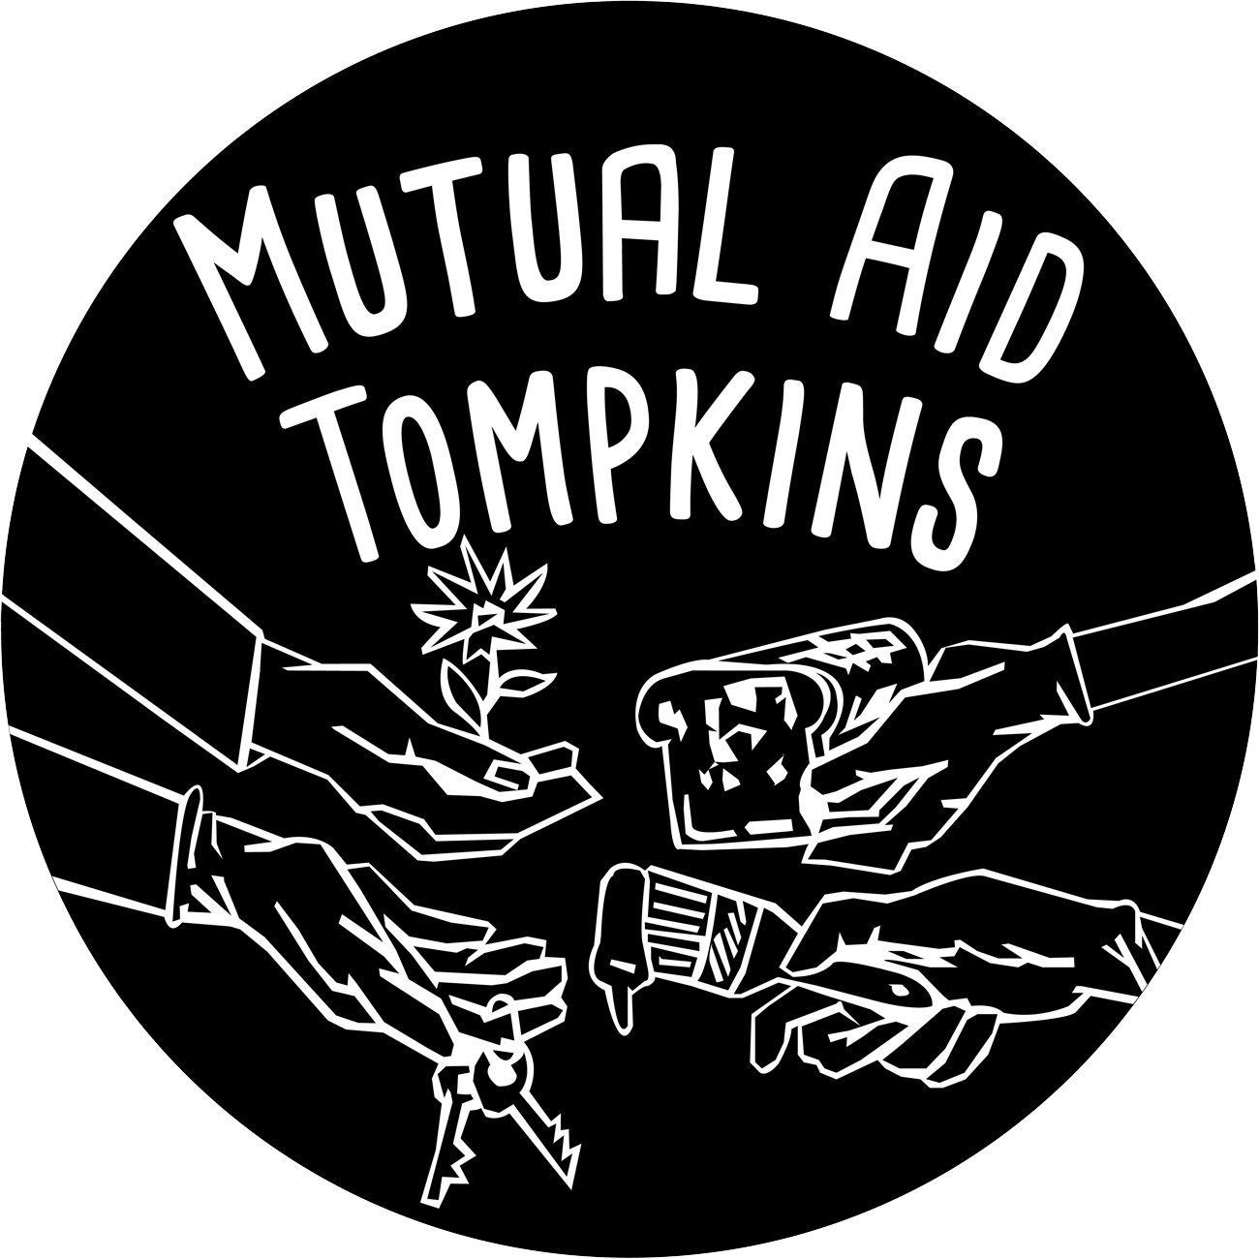

Neighborhood Food Sharing is a project of Mutual Aid Tompkins. We are working with B&B Flooring to build Food Sharing Cabinets to be placed across the county in locations where residents face food insecurity and lack of transportation.

We have a food sharing cabinet Location List. Please take a look and see if there is a cabinet in your area or proposal for a cabinet in your area.

Community members are encouraged to find members of their local community to be the point people for the cabinet. This would mean checking in on it and checking up with people accessing the cabinet to see if there are additional items that are needed.

We are working with the Friendship Donations Network as well as volunteer community members to keep the cabinets stocked with food and other essential items.

If you would like to support the building of a cabinet, please send the money directly to B&B Flooring. Estimated cost per pod is $100.
Please email communityaidtompkins@gmail.com with any questions.
For more information visit our website at https://mutualaidtompkins.com/

