TOWN OF ULYSSES
10 Elm Street, Trumansburg, NY 14886
ulysses.ny.us

Town Supervisor (607) 387-5767, Ext 232 supervisor@ulysses.ny.us
Town Clerk (607) 387-5767, Ext 221 clerk@ulysses.ny.us
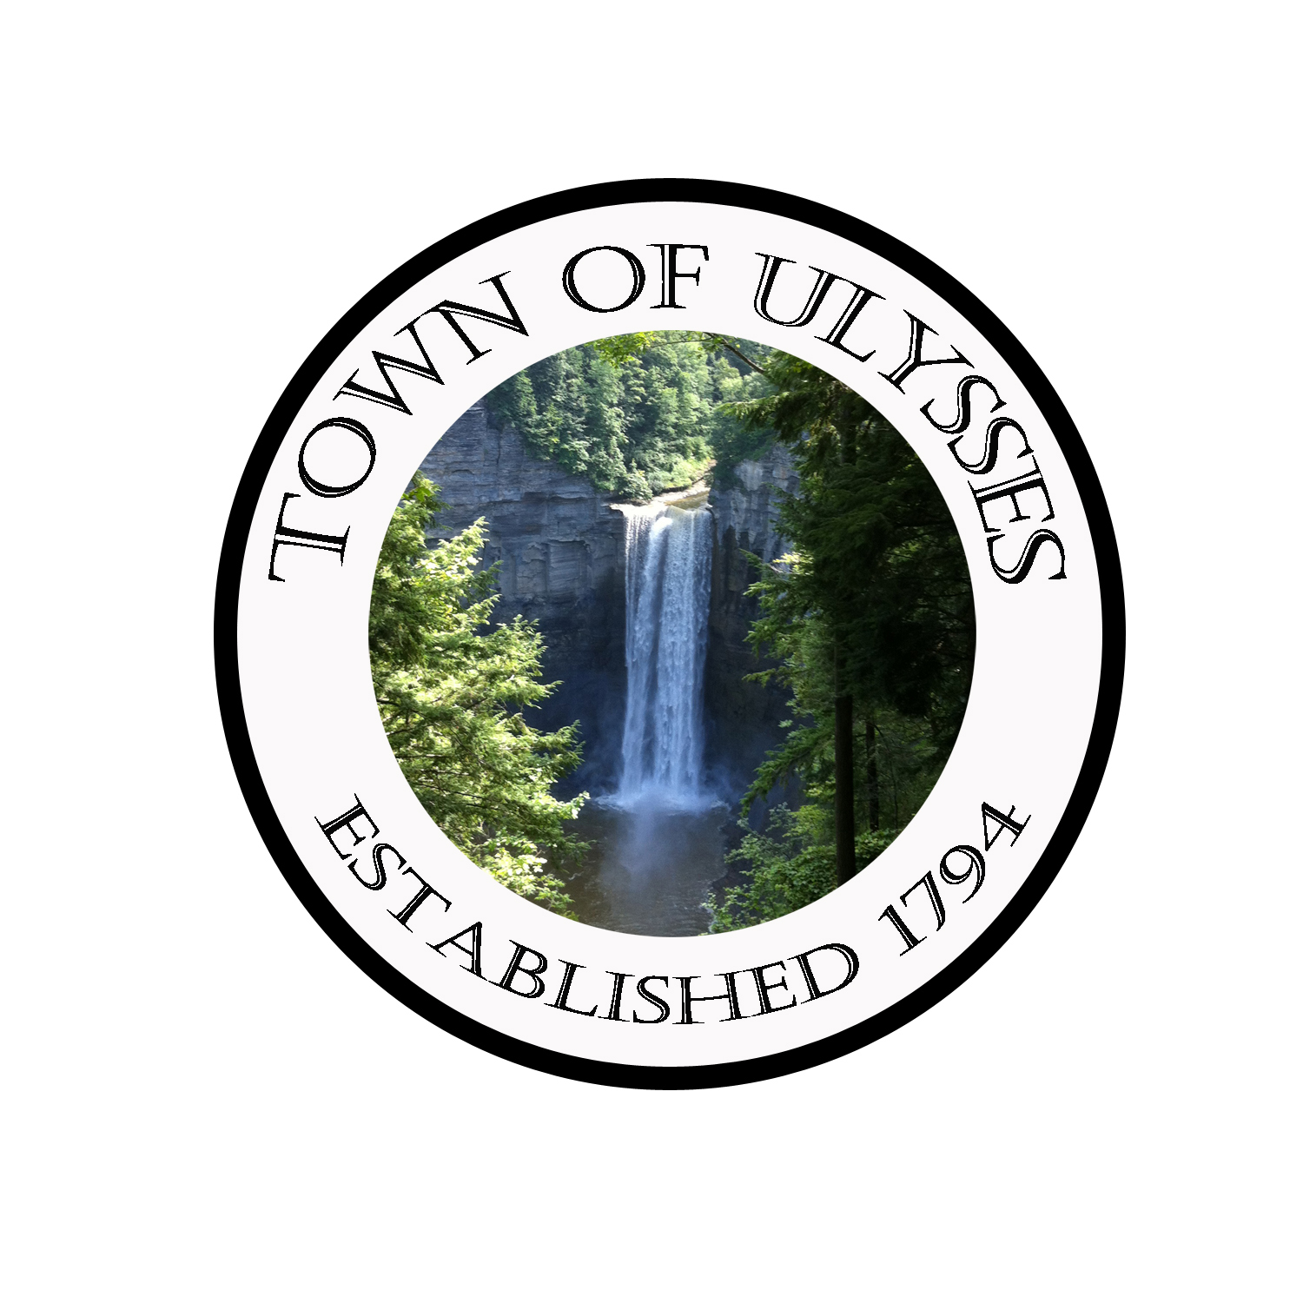

Building & Code Enforcement Office
607-387-9778 ext. 231
Buildings & Code Enforcement Report for July 2021

Submitted at August 2021 Town Board Meeting

Building Permits issued |  | 8
Plan Reviews |  | 4
Certificate of Occupancy issued |  | 1
Permits Renewed |  | 0
Complaints Received |  | 1
Complaints Resolved |  | 1
Inspections (Footers, Foundations, Plumbing, Insulation, roofing, Pools, Etc.) |  | 30 Plus  3 Reinspection’s
New Site Inspections |  | 3
Building Review Consultations (pre-plan meetings, Future Building/Remodeling) |  | 2
Fire Safety Inspections |  | Ongoing
Code Training Seminars
County Assessment, Town, DOS Reports |  | 3
Open property in violation cases |  | 7
Property violations resolved 0

Value of Permits issued: $136,111.00

Building Permit fees collected for month: $932.00

Respectfully Submitted,

Mark Washburn
Mark Washburn – Building & Fire Code Enforcement Officer

