Public Employer

Public Health Emergency Plan: Communicable Diseases

TOWN OF ULYSSES

Date of draft: 2/4/2021
This plan has been developed in accordance with NYS legislation S8617B/A10832

Promulgation
This plan has been developed in accordance with the amended New York State Labor Law section 27-c and New York State Education Law paragraphs k and l of subdivision 2 of section 2801-a (as amended by section 1 of part B of chapter 56 of the laws of 2016), as applicable.
This draft was provided to Teamsters Local 317 on February 4th, 2021 for feedback.
This plan has been developed with the input of Teamsters Local 317, as required by the amended New York State Labor Law.
No content of this plan is intended to impede, infringe, diminish, or impair the rights of us or our valued employees under any law, rule, regulation, or collectively negotiated agreement, or the rights and benefits which accrue to employees through collective bargaining agreements, or otherwise diminish the integrity of the existing collective bargaining relationship.
This plan has been approved in accordance with requirements applicable to the agency, jurisdiction, authority, or district, as represented by the signature of the authorized individual below.

--
As the authorized official of Town of Ulysses, I hereby attest that this plan has been developed, approved, and placed in full effect in accordance with S8617B/A10832 which amends New York State Labor Law section 27-c and New York State Education Law paragraphs k and l of subdivision 2 of section 2801-a (as amended by section 1 of part B of chapter 56 of the laws of 2016), as applicable, to address public health emergency planning requirements.

Signed on this day: date
By: name of signatory | Signature: _______________________________
Title: title of signatory

Record of Changes

Date of Change | Description of Change | Implemented by

Table of Contents
Promulgation 1
Record of Changes 2
Purpose, Scope, Situation Overview, and Assumptions 5
Purpose 5
Scope 5
Situation Overview 5
Planning Assumptions 5
Concept of Operations 6
Mission Essential Functions 6
Essential Positions 8
Reducing Risk Through Remote Work and Staggered Shifts 9
Onsite Work 9
In-Person Presence Onsite: Quarantine Decision-Making 10
Remote Work Protocols 11
Staggered Shifts 11
Personal Protective Equipment 12
Staff Exposures, Cleaning, and Disinfection 12
Staff Exposures 13
Potential Exposure Staff Notification Process 13
Returning to Work After Illness 15
Cleaning and Disinfecting 15
Employee and Contractor Leave 16
If Staff Require COVID-Related Paid Time Off 16
Documentation of Work Hours and Locations 17
Building Use Calendar 17
Town Hall Sign-In Contact Tracing Form 17
Housing for Essential Employees 17

Purpose, Scope, Situation Overview, and Assumptions

Purpose
This plan has been developed in accordance with the amended New York State Labor Law section 27-c and New York State Education Law paragraphs k and l of subdivision 2 of section 2801-a (as amended by section 1 of part B of chapter 56 of the laws of 2016), as applicable. These laws were amended by the passing of legislation S8617B/A10832 signed by the Governor of New York State on September 7, 2020, requiring public employers to adopt a plan for operations in the event of a declared public health emergency involving a communicable disease. The plan includes the identification of essential positions, facilitation of remote work for non-essential positions, provision of personal protective equipment, and protocols for supporting contact tracing.

Scope
This plan was developed exclusively for and is applicable to Town of Ulysses. This plan is pertinent to a declared public health emergency in the State of New York which may impact our operations; and it is in the interest of the safety of our employees and contractors, and the continuity of our operations that we have promulgated this plan.

Situation Overview
On March 11, 2020 the World Health Organization declared a pandemic for the novel coronavirus which causes the COVID-19 severe acute respiratory syndrome. This plan has been developed in accordance with amended laws to support continued resilience for a continuation of the spread of this disease or for other infectious diseases which may emerge and cause a declaration of a public health emergency.
The health and safety of our employees and contractors is crucial to maintaining our mission essential operations. We encourage all employees and contractors to use CDC Guidance for Keeping Workplaces, Schools, Homes, and Commercial Establishments Safe. The fundamentals of reducing the spread of infection include:
- Using hand sanitizer and washing hands with soap and water frequently, including:
  - After using the restroom
  - After returning from a public outing
  - After touching/disposing of garbage
  - After using public computers, touching public tables, and countertops, etc.
- Practice social distancing when possible
- If you are feeling ill or have a fever, notify your supervisor immediately and go home
- If you start to experience coughing or sneezing, step away from people and food, cough or sneeze into the crook of your arm or a tissue, the latter of which should be disposed of immediately
- Clean and disinfect workstations at the beginning, middle, and end of each shift
- Wear a mask at all times in the building, unless you are in your office with the door closed.
- Other guidance which may be published by the CDC, the State Department of Health, or County health officials.

Planning Assumptions
This plan was developed based on information, best practices, and guidance available as of the date of publication. The plan was developed to largely reflect the circumstances of the current Coronavirus pandemic but may also be applicable to other infectious disease outbreaks.
The following assumptions have been made in the development of this plan:
- The health and safety of our employees and contractors, and their families, is of utmost importance
- The circumstances of a public health emergency may directly impact our own operations
- Impacts of a public health emergency will take time for us to respond to, with appropriate safety measures put into place and adjustments made to operations to maximize safety
- The public and our constituency expects us to maintain a level of essential operations
- Resource support from other jurisdictions may be limited based upon the level of impact the public health emergency has upon them
- Supply chains, particularly those for personal protective equipment (PPE) and cleaning supplies, may be heavily impacted, resulting in considerable delays in procurement
- The operations of other entities, including the private sector (vendors, contractors, etc.), non-profit organizations, and other governmental agencies and services may also be impacted due to the public health emergency, causing delays or other disruptions in their services
- Emergency measures and operational changes may need to be adjusted based upon the specific circumstances and impacts of the public health emergency, as well as guidance and direction from public health officials and the governor
- Per S8617B/A10832, ‘essential employee’ is defined as a public employee or contractor that is required to be physically present at a work site to perform their job
- Per S8617B/A10832, ‘non-essential employee’ is defined as a public employee or contractor that is not required to be physically present at a work site to perform their job

Concept of Operations
The Town Board of the Town of Ulysses, their designee, or their successor, holds the authority to execute and direct the implementation of this plan. Implementation, monitoring of operations, and adjustments to plan implementation may be supported by additional personnel, at the discretion of the Town Supervisor.
Upon the determination of implementing this plan, all employees and on-site contractors of Town of Ulysses shall be notified by email, which will include a request to confirm receipt, with additional information and updates provided on a regular basis. The general public will be notified of pertinent operational changes by way of the Town’s website, signage at Town Hall and the Town e-newsletter. Other interested parties, such as vendors, will be notified by phone and/or email as necessary. The Town’s Safety Committee and Town Clerk Office will maintain communications with the public and constituents as needed throughout the implementation of this plan.
The Town Board of the Town of Ulysses, their designee, or their successor, will maintain awareness of information, direction, and guidance from public health officials and the Governor’s office, directing the implementation of changes as necessary.
Upon resolution of the public health emergency, the Supervisor of the Town of Ulysses, their designee, or their successor, will direct the resumption of normal operations or operations with modifications as necessary.

Mission Essential Functions
When confronting events that disrupt normal operations, the Town of Ulysses is committed to ensuring that essential functions will be continued even under the most challenging circumstances.
Essential functions are those functions that enable an organization to:
- Maintain the safety of employees, contractors, and our constituency
- Provide vital services
- Provide services required by law
- Sustain quality operations
- Uphold the core values of the Town of Ulysses
The Town of Ulysses has identified as critical only those priority functions that are required or are necessary to provide vital services. During activation of this plan, all other activities may be suspended to enable the organization to concentrate on providing the critical functions and building the internal capabilities necessary to increase and eventually restore operations. Appropriate communications with employees, contractors, our constituents, and other stakeholders will be an ongoing priority.
Essential functions are prioritized according to:
- The time criticality of each essential function
- Interdependency of one function to others
- The recovery sequence of essential functions and their vital processes
Priority 1 identifies the most essential of functions, with priority 4 identifying functions that are essential, but least among them.
The mission essential functions for the Town of Ulysses have been identified as:
Essential Function | Description | Priority
Information disbursement to Town Residents | The Town distributes information pertaining to the emergency and related resources on a regular basis. Often, the Town assists the County and State in sharing pertinent information. | 1
Information Technology | Contractual support that provides hardware and software for the town. Maintains the town’s network and phone system. This function also includes email communication. | 1
Tax Collection | As required by law, the Clerk’s office is to hold hours open to the public during tax collection season. | 1
Road Maintenance | Short term community safety during snow and rain events and the maintenance of equipment to do so. Maintaining the roads serves the long-term financial and upholds the values of the Town. | 1
Water Supply Operations and Maintenance | To ensure clean drinking water for Town residents on municipal water. | 1
Court | As required by law. | 2
Code Enforcement | As required by law, and to maintain the health and safety of Ulysses residents. | 2
Zoning Enforcement | To ensure the long-term environmental health of the Town. | 2
Marriage Licenses | To maintain the standard of living conducive to the core values of the Town. | 3
Records Management & Security | To maintain the long-term integrity of local government and democracy. | 1
Payroll | Ensuring the financial security of Town employees during an emergency. | 1
Mail Processing | To maintain communications with external contacts. | 2
Bills Payable | As required by law and current contracts. | 2

Essential Positions
Each essential function identified above requires certain positions on-site to effectively operate. The table below identifies the positions or titles that are essential to be staffed on-site for the continued operation of each essential function. Note that while some functions and associated personnel may be essential, some of these can be conducted remotely and do not need to be identified in this section.
Essential Function | Essential Positions/Titles | Justification for Each
Information disbursement to Town Residents | - Town Clerk  - Deputy Clerk  - Town Supervisor  - Emergency Preparedness Coordinator | Onsite presence required due to methods of information collecting.
Information Technology | - IT Contractors | Server onsite.
Tax Collection | - Clerk  - Deputy Clerk | In person office hours required by law.
Road Maintenance | - Highway Superintendent  - MEOs (4) | Work done in the field and at the Highway Barn.
Water Supply Operations and Maintenance | - Water District Operator  - Water District Laborer | Work done in the field.
Court | - Court Clerk  - Judges (2) | Access to records room required. Access to technology at the Town Hall.
Code Enforcement | - Code Officer  - Deputy Code Officer | Access to records required.
Zoning Enforcement | - Environmental Planner | Access to records required.
Marriage Licenses | - Clerk  - Deputy Clerk | In person requirements.
Records Management & Security | - Clerk  - Deputy Clerk | Maintenance of physical records.
Payroll | - Budget Officer  - Bookkeeper | Hard copy of timesheets.
Mail Processing | - Clerk  - Deputy Clerk | Physical processing of hard copy mail.
Bills Payable | - Supervisor  - Town Board (4)  - Bookkeeper  - Clerk  - Deputy Clerk | Hard copy administration of bills payable, including vouchering and signing of checks
Other Financial | - Bookkeeper  - Budget Officer | Deposits, transfers, etc.

Court Functions Note
It is important to note that Justice Court is a vital component of town government, with Justice Court functions budgeted and supported by the Town Board and Town Supervisor. However, we recognize that the New York State Office of Court Administration holds dominion over Justice Courts and, as such, may issue orders which suspend or alter the hours of operation or means by which Justice Courts operate; which may not fully align with this plan or other measures taken by the Town Board or Town Supervisor. As such, the Town Board, Town Supervisor, and Town Clerk will coordinate as necessary with Justice Court personnel to ensure safe and effective continuity of town Justice Court.

Reducing Risk Through Remote Work and Staggered Shifts
Through assigning certain staff to work remotely and by staggering work shifts, we can decrease crowding and density at work sites and on public transportation.

Onsite Work
Staff and elected officials must adhere to the following requirements when inside any Town facility:
- Masks that adhere to the WHO guidelines must be worn at all times.
- Maintain a 6-foot distance from others.
  - Exception: when behind a closed door and alone.
- If unable to ride in separate vehicles: always wear your mask, with the windows cracked for airflow when possible.

Town Hall guidelines:
- For staff and elected officials who need to conduct work at the Town Hall, a building use calendar is to be used to stagger the number of people at the Town Hall at a given time.
- Those who need to come to the Town Hall should block out the projected time frame they are to be onsite and work with other staff and elected officials on staggered scheduling as needed.
Highway Department guidelines:
- To reduce density, one Machine Equipment Operator (MEO) will be assigned per vehicle.
- If more than one MEO is needed/ vehicle, all employees shall wear masks and crack the windows to mitigate possible viral transmission.
- To reduce possible transmission through surfaces, whenever possible the Highway Superintendent shall be the primary operator of the truck used to load salt into plowing trucks operated by MEOs.
- Social distancing and/or staggered breaks will be observed by Highway employees in the Town Barn break room.

In-Person Presence Onsite: Quarantine Decision-Making
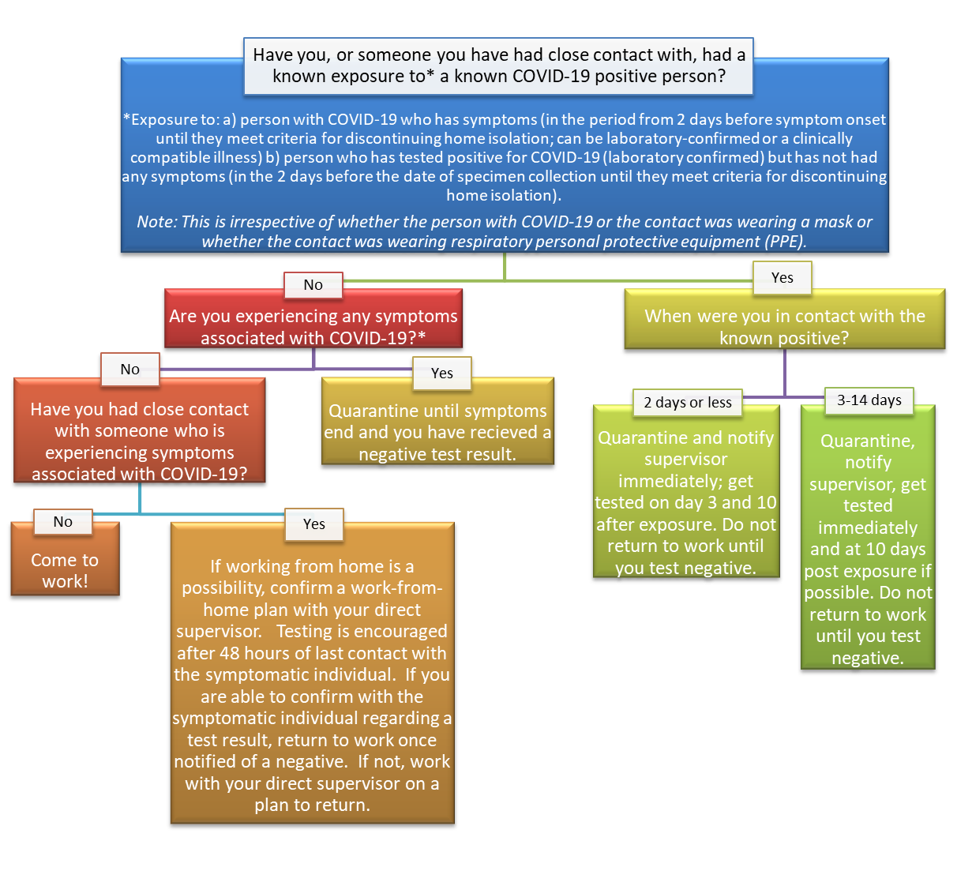
Quarantine in this context means: do not come to work, and, adhere to all other WHO quarantine guidelines
Please note that it is not the intention for this chart to be inclusive of all possible scenarios. Please work with your direct supervisor regarding decision making that is not reflected in the below. In these pandemic conditions, we have to ask staff to remain vigilant in both their professional lives as well as their personal lives. Maintaining high standards of hygiene at all times, as well as minimizing the number of people you have close contact with, is a professional courtesy that will help ensure the health of your co-workers as well as the Town’s ability to provide services.

Remote Work Protocols
Non-essential employees and contractors who are able to accomplish their functions remotely will be enabled to do so at the greatest extent possible. Working remotely requires:
- Identification of staff who will work remotely
- Approval and assignment of remote work
- Equipping staff for remote work, which may include:
  - Internet capable laptop
  - Access to VPN and/or secure network drives
    - You will need a home computer that will connect with your work computer. You will be able to view and control your work computer and access your files and programs. Your work computer will need to be on for this to work.
      - Initial set up requires assistance from IT Contractor Jeff Burns
        - Download the following VNC viewer software: https://www.dropbox.com/s/o453ojrmdnbp7ja/vnc.zip?dl=0
        - Unzip into a folder and install – at one point it will ask if want viewer and sever (uncheck server apps) if you do not uncheck server they will want money.
        - 199.167.199.14:5909
      - Instructions (NOTE: save this information for your home office):
        - Click on the VNC Viewer icon on your home computer.
        - A box showing the IP address will come up. Click OK.
        - Another box will appear asking for your password.
        - Then you will be able to view your work computer.
        - Enter your password to log in.
        - When done, restart your work computer so that it stays on but is protected from hackers.
  - Remote monitoring of office voicemail
    - Checking Voicemail Remotely (NOTE: save this information for your home office):
      - Call your town phone number.
      - While voicemail is playing, press **.
      - Enter your extension and mailbox password, then the # key, and follow prompts.
As possible, ‘essential’ staff may be assigned to work remotely for part of their work week to reduce exposures. Further, business hours and locations of Town government may be altered to best accommodate public health protective actions for employees and the public. Alterations to building access and the means by which the public interacts with Town employees may also take place to support these protections. Protective actions may include, but are not limited to occupancy restrictions, protective barriers, and increased conduct of business by internet, phone, or other means. Protective actions will be taken in accordance with County and State Health Department, and CDC guidelines and requirements.

Staggered Shifts
Implementing staggered shifts may be possible for personnel performing duties which are necessary to be performed on-site but perhaps less sensitive to being accomplished only within core business hours. As possible, management will identify opportunities for staff to work outside core business hours as a strategy of limiting exposure. Regardless of changes in start and end times of shifts, Town of Ulysses will ensure that employees are provided with their typical or contracted minimum work hours per week. Staggering shifts requires:
- Identification of positions for which work hours will be staggered
- Supervisor approval and assignment of changed work hours

Personal Protective Equipment
The use of personal protective equipment (PPE) to reduce the spread of infectious disease is important to supporting the health and safety of our employees and contractors. PPE which may be needed can include:
- Masks
- Face shields
- Gloves
- Disposable gowns and aprons
Note that while cleaning supplies are not PPE, there is a related need for cleaning supplies used to sanitize surfaces, as well as hand soap and hand sanitizer. The Coronavirus pandemic demonstrated that supply chains were not able to keep up with increased demand for these products early in the pandemic. As such, we are including these supplies in this section as they are pertinent to protecting the health and safety of our employees and contractors.
Protocols for providing PPE include the following:
- Identification of need for PPE based upon job duties and work location
  - Any staff person requiring PPE can contact the Clerks Office, or the Ulysses Emergency Preparedness Contact to set up a time for pick up or delivery of PPE.
- Procurement of PPE
  - As specified in the amended law, public employers must be able to provide at least two pieces of each required type of PPE to each essential employee and contractor during any given work shift for at least six months
  - Public employers must be able to mitigate supply chain disruptions to meet this requirement
- Storage of, access to, and monitoring of PPE stock
  - PPE must be stored in a manner which will prevent degradation
  - Employees and contractors must have immediate access to PPE in the event of an emergency
  - The supply of PPE must be monitored to ensure integrity and to track usage rates
    - PPE is kept at various points of use as well as in the Records Room.
    - The Clerk and Supervisor’s office monitors supplies to ensure an 8 week supply of all PPE.
    - The Clerk’s office reorders when necessary.
      - Common vendors:
        - Staples, online ordering
        - ShurSave
        - Tompkins County Department of Emergency Response

Staff Exposures, Cleaning, and Disinfection

Staff Exposures
Staff exposures are organized under several categories based upon the type of exposure and presence of symptoms. Following CDC guidelines, we have established the following protocols:
- Staff and visitors entering town buildings and staying longer than 15 minutes must sign a contact tracing log to assist with notifications for potential exposures.
- If employees or contractors are exposed to a known case of communicable disease that is the subject of the public health emergency (defined as a ‘close contact’ with someone who is confirmed infected, which is a prolonged presence within six feet with that person):
- Potentially exposed employees or contractors who do not have symptoms should remain at home or in a comparable setting and practice social distancing for the lesser of 14 days or other current CDC/public health guidance for the communicable disease in question.
  - As possible, these employees will be permitted to work remotely during this period of time if they are not ill.
  - See the section titled Documentation of Work Hours and Locations for additional information on contact tracing

Potential Exposure Staff Notification Process
As required by law, confidentiality regarding health-related matters will remain a protected right of the persons impacted.

- CDC guidelines for COVID-19 provide that critical essential employees may be permitted to continue work following potential exposure, provided they remain symptom-free and additional precautions are taken to protect them, other employees and contractors, and our constituency/public.
  - Due to the small staff size at Ulysses, staff who feel that, due to required work activities, they cannot follow the In-Person Presence Onsite: Quarantine Decision-Making chart outlined in a prior section of this plan (page 9), need to speak to their direct supervisor to problem solve the specifics of the situation.
  - Additional precautions will include the requirement of the subject employee or contractor, as well as others working in their proximity, to wear appropriate PPE at all times to limit the potential of transmission.
  - In-person interactions with the subject employee or contractor will be limited as much as possible.
  - Work areas in which the subject employee or contractor are present will be disinfected according to current CDC/public health protocol at least every hour, as practical. See the section on Cleaning and Disinfection for additional information on that subject.
  - If at any time they exhibit symptoms, refer to item B below.
  - Board appointed Emergency Preparedness Coordinator is to ensure that these protocols are followed.
- If an employee or contractor exhibits symptoms of the communicable disease that is the subject of the public health emergency:
- Employees and contractors who exhibit symptoms in the workplace should be immediately separated from other employees, customers, and visitors. They should immediately be sent home with a recommendation to contact their physician.
- Employees and contractors who exhibit symptoms outside of work should notify their supervisor and stay home, with a recommendation to contact their physician.
- Employees experiencing symptoms should provide their supervisor with the names of those with whom they have been in contact through the workplace.
- Employees should not return to work until they have met the criteria to discontinue home isolation per CDC/public health guidance and have consulted with a healthcare provider.
- When possible, an employee who has been isolated or in quarantine should only return to work with a Health Department release and/or a negative test result.
- Board appointed Emergency Preparedness Coordinator is to ensure that these protocols are followed.
- If an employee or contractor has tested positive for the communicable disease that is the subject of the public health emergency:
- Apply the steps identified in item B, above, as applicable.
- Areas occupied for prolonged periods of time by the subject employee or contractor will be closed off.
  - CDC guidance for COVID-19 indicates that a period of 24 hours is ideally given before cleaning, disinfecting, and reoccupation of those spaces will take place. If this time period is not possible, a period of as long as possible will be given. CDC/public health guidance for the disease in question will be followed.
  - Any common areas entered, surfaces touched, or equipment used shall be cleaned and disinfected immediately.
  - See the section on Cleaning and Disinfection for additional information on that subject.
- Identification of potential employee and contractor exposures will be conducted
  - If an employee or contractor is confirmed to have the disease in question refer to staff notification chart. Confidentiality shall be maintained as required by law.
  - Apply the steps identified in item A, above, as applicable, for all potentially exposed personnel.
- Board appointed Emergency Preparedness Coordinator is to ensure that these protocols are followed.

Returning to Work After Illness
We recognize there may be nuances or complexities associated with potential exposures, close contacts, symptomatic persons, and those testing positive. We will follow CDC/public health recommendations and requirements and coordinate with our local public health office for additional guidance and support as needed.
Note that these recommendations do not apply to persons with severe COVID-19 or with severely weakened immune systems (immunocompromised). Individuals should always consult their doctor prior to returning to in-person work.

Cleaning and Disinfecting

CDC/public health guidelines will be followed for cleaning and disinfection of surfaces/areas. Present guidance for routine cleaning during a public health emergency includes:
- As possible, employees and contractors will clean their own workspaces in the beginning, middle, and end of their shifts, at a minimum.
  - High traffic/high touch areas and areas which are accessible to the public/constituents will be disinfected at least hourly.
    - Staff who host members of the public inside a Town facility need to ensure that they disinfect areas used by the public immediately upon their departure.
  - Board appointed Emergency Preparedness Coordinator is to ensure that these protocols are followed.
- Staff tasked with cleaning and disinfecting areas will be issued and required to wear PPE appropriate to the task.
- Soiled surfaces will be cleaned with soap and water before being disinfected.
- Surfaces will be disinfected with products that meet EPA criteria for use against the virus in question and which are appropriate for that surface.
- Staff will follow instructions of cleaning products to ensure safe and effective use of the products.

Employee and Contractor Leave
Public health emergencies are extenuating and unanticipated circumstances in which the Town of Ulysses is committed to reducing the burden on our employees and contractors. The Families First Coronavirus Response Act provided requirements related to the COVID-19 pandemic, which form the policies outlined below. This policy may be altered based upon changes in law or regulation, as applicable.
It is our policy that employees of the Town of Ulysses will not be charged with leave time for testing and are permitted up to 3-hours of paid time off for receiving vaccinations. Employees will be provided with up to two weeks (80 hours) of paid sick leave at the employee’s regular rate of pay for a period which the employee is unable to work due to quarantine (in accordance with federal, state, or local orders or advice of a healthcare provider), and/or experiencing symptoms and seeking medical diagnosis.
Further, the Town of Ulysses will provide up to two weeks (80 hours) of paid sick leave at two-thirds the employee’s regular rate of pay if the employee is unable to work because of a bona fide need to care for an individual subject to quarantine (pursuant to federal, state, or local orders or advice of a healthcare provider), or to care for a child (under 18 years of age) whose school or child care provider is closed or unavailable for reasons related to the public health emergency, and/or the employee is experiencing a substantially similar condition as specified by the CDC/public health officials. This provision may be modified if an employee is able to effectively work remotely and the need exists for them to do so.
Additionally, Town of Ulysses will provide up to an additional 10 weeks of paid expanded family and medical leave at two-thirds of the employee’s regular rate of pay where an employee, who has been employed for at least 30 calendar days by Town of Ulysses, is unable to work due to a bona fide need for leave to care for a child whose school or child care provider is closed or unavailable for reasons related to the public health emergency. This provision may be modified if an employee is able to effectively work remotely and the need exists for them to do so.
Additional provisions may be enacted based upon need and the guidance and requirements in place by federal and state employment laws, FMLA, executive orders, and other potential sources.
Contractors, either independent or affiliated with a contracted firm, are not classified as employees of the Town of Ulysses, and as such are not provided with paid leave time by the Town of Ulysses, unless required by law.

If Staff Require COVID-Related Paid Time Off
As soon as it is possible, staff should contact their immediate supervisor if they or an immediate family member is diagnosed with the communicable disease subject of the public health emergency regarding paid time off.
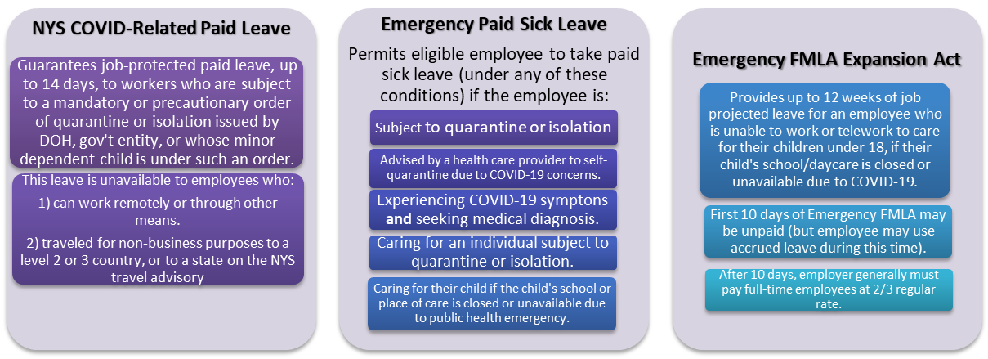

Documentation of Work Hours and Locations
In a public health emergency, it may be necessary to document work hours and locations of each employee and contractor to support contact tracing efforts and for potential federal/state reimbursements. Identification of locations shall include on-site work, off-site visits. This information may be used by Town of Ulysses to support contact tracing within the organization and may be shared with local public health officials.

Building Use Calendar
- Staff and elected official who are at the Town Hall longer than 15 minutes, use this Building Use Calendar here:
  - https://calendar.google.com/calendar/u/0?cid=MzBrNDZkcjk0MHAwZm1tY2JvMm00bjA2c2NAZ3JvdXAuY2FsZW5kYXIuZ29vZ2xlLmNvbQ
  - Staff who require technical assistance in meeting this requirement should as the Emergency Preparedness Coordinator for training.

Town Hall Sign-In Contact Tracing Form
All staff and elected officials are required to sign in and out of the Town Hall when they are present.
- Fill out sign in completely: First and last name, address, phone number, time in and time out.
  - Do not write "on file" for any of this information
- "See above" is okay if the person has completely filled the log out on the same page and above the slot being completed.
- These specific requests are to ensure that Contact Tracers can do their job.

Housing for Essential Employees
There are circumstances within a public health emergency when it may be prudent to have essential employees lodged in such a manner which will help prevent the spread of the subject communicable disease to protect these employees from potential exposures, thus helping to ensure their health and safety and the continuity of the Town of Ulysses’ essential operations.
If such a need arises, the Town Board-appointed Emergency Preparedness Coordinator will coordinate arrangements. If suitable temporary housing is unable to be procured, the Emergency Preparedness Coordinator will work with the Tompkins County Department of Emergency Response to help identify and arrange for these housing needs.

Please visit the Department of Labor for the most current policies pertaining to this legislation.

