2022 Town of Ulysses Preliminary Budget
Information for the October 26, 2021Public Hearing
Prepared by Nancy Zahler and Budget Officer Michelle E. Wright on behalf of the Ulysses Town Board

Ulysses Town Board Members

Michael Boggs
Mary Bouchard
Richard Goldman
Katelin Olson, Deputy Supervisor
Nancy Zahler, Supervisor

BUILDING ON THE 2021 BUDGET The 2022 budget is based on our adopted and modified 2021 Budget which was very conservative in response to COVID-19. The Ulysses Town Board has been monitoring both the revenues and expenses carefully throughout 2021 as the pandemic has continued with a gradual re-opening of the economy. Building on a very positive audit from the NYS Comptroller on our finances and procedures, Budget Officer Michelle E. Wright and the Town Board have been analyzing our income sources, including sales tax, our available fund balances or savings, and the reserves needed for specific future expenses.. In addition, Blixy Taetzsch, our new Bookkeeper, improved the monthly financial reports to enable the Town Board and the public to track the anticipated and actual income and spending more easily for greater accountability and fiscal planning.

2022 BUDGET PROCESS The process began in August 2021 when Department heads were asked to evaluate current spending and revenues and to request funding to maintain existing services and for new cost-savings initiatives for 2022. The Supervisor’s office submitted a Tentative Budget on September 30, 2021 that considered the department requests and recommended some additions to various town reserves to save for future needs. To make our process more transparent, with help from Town Clerk Carissa Parlato, the Town Board invited non-profits that provide services to address the health, safety, and well-being of our residents to request funding. The requests were reviewed by the Town Board and included in the Tentative Budget.

The full Town Board carefully reviewed every line item in the Tentative Budget during six open review sessions from October 6-19th which included opportunities for public comment. The Town Board made changes to incorporate updated information and adjusted spending and revenue estimates. This proposasl outlines the Town Board’s priorities and achieves what it believes is a high level of town services at a reasonable tax rate for these uncertain times.

BACKGROUND ON MUNICIPAL BUDGETING

Section 6-12 of the NYS Home Rule Statute allows town boards to budget for and adopt local laws concerning the property, affairs or government of the town, including: the care of highways; the protection and enhancement of its physical and visual environment; and the protection, order, conduct, safety, health and well-being of persons or property.

The annual budget for any municipality is a policy document that reflects local values and describes the services and priorities the elected officials believe are in the best interest of its residents. A public hearing is not only required but it is an opportunity for the Town Board to inform our residents about how the proposed services and priorities will be funded and to seek feedback on the proposed spending and taxation levels. The structure and format of the budget are defined by the NYS Comptroller’s Office and are not always labeled with user-friendly titles. This narrative is an effort to offer a clearer summary of the proposed budget. A few key points:

- The Town Budget provides some services for all town residents through the A General Fund and DA Highway fund. Additional services are provided for just those residing outside the Village of Trumansburg and are included in the B Fund and the DB Highway Fund. These are two distinct tax bases and there are separate tax rates to reflect this distinction.
- Town tax bills vary depending on whether you live in the Village or outside and on the assessed value of your property.
- The budget must be balanced. The total proposed appropriations or spending must be offset by revenues which can come from sales tax, mortgage tax, state and county aid, fees for services, town savings and/or property taxes.
- The tax levy (or the number of dollars raised by property taxes) is calculated after all other forms of revenue are used to offset total spending (appropriations). The gap is filled by taxpayers through property taxation. The tax rate/$1000 of assessed value is determined by the total to be raised by taxes (the tax levy) divided by the total assessed value of all property in the town and multiplied by 1000.
Tax Rate = (Tax Levy $÷ TAV) x 1000$
- If you live within a water district, your assessed cost is based on the number of units in each district and costs are distributed proportionally. Your tax bill will reflect your units and your share of any debt service as well as operation and maintenance costs.

THE NUMBERS AT A GLANCE:

The Preliminary 2022 budget proposes to spend a total of $3,899,292 of which $1,510,230 or 39% will come from property taxes.

The 2022 tax cap levy limit for the Town of Ulysses is $1,542,539 - permitting up to $ 69,510 or a 4.72% increase in taxation over 2021. The Town Board voted unanimously not to give itself the ability to override the tax cap and it has not done so.

The $1,510,230 in projected property tax revenue represents a 2.53% increase over the 2021 tax levy, or $37,201 more in taxes. With $32,309 remaining in the tax levy cap limit, the 2022 Preliminary budget is well below the tax cap levy limit and below the 10-year average tax levy change of 2.97%.

The taxable assessed value of properties in the whole town increased just slightly at 0.7% to a new total of
$ 555,992,106. (See trend charts of taxable values and tax rate changes over time on p. 6)

The portion of the total taxable assessed value for Fire, EMS and other services to those outside the Village is
$ 420,675,510 or just 0.8% more than in 2021.

The general town wide tax rate, not including Fire/EMS or Water Districts, proposed in the 2022 Preliminary Budget is $ 1.27 per thousand dollars of assessed property value, which includes the Village of Trumansburg. In 2021, the Town of Ulysses tax rate was the lowest in Tompkins County. 2022 comparisons are not available.

The tax rate for properties in the Fire and Ambulance district was calculated using updated and reduced amounts from the Village received on 9/30. The tax rate of $ 1.35 per thousand for properties outside the Village of Trumansburg raises $569,362 in taxes to offset $644,663 in total costs. Ambulance fees and savings also partially offset the total cost. The taxes raised to pay for Fire & EMS represent 38% of all taxes raised.

When combined, the total tax rate for Town residents, outside of the Village, including Fire & EMS is
$2.62/$1000 or a tax rate increase of 1.55% over 2021 resulting in a 2.62% increase in tax levy. The tax rate for Village of Trumansburg residents is proposed to be $1.27/$1000, resulting in a 4.3% increase in their tax levy.

The total taxes levied, when water districts are added, increases by 2.53% in the 2022 Preliminary Budget.

The tax bill on a home in the Town outside the Village with a 2019 median value of $216,000* will be $565.94 or $8.64 more than 2021. The same home in the Village will be $273.60 or $9.30 more and taxes on the same home in Water District 3 will be $1181.16 or an increase of $16.58

*Source: 2019 American Community Survey from US Census.
THE BUDGET AT A GLANCE IN PICTURES

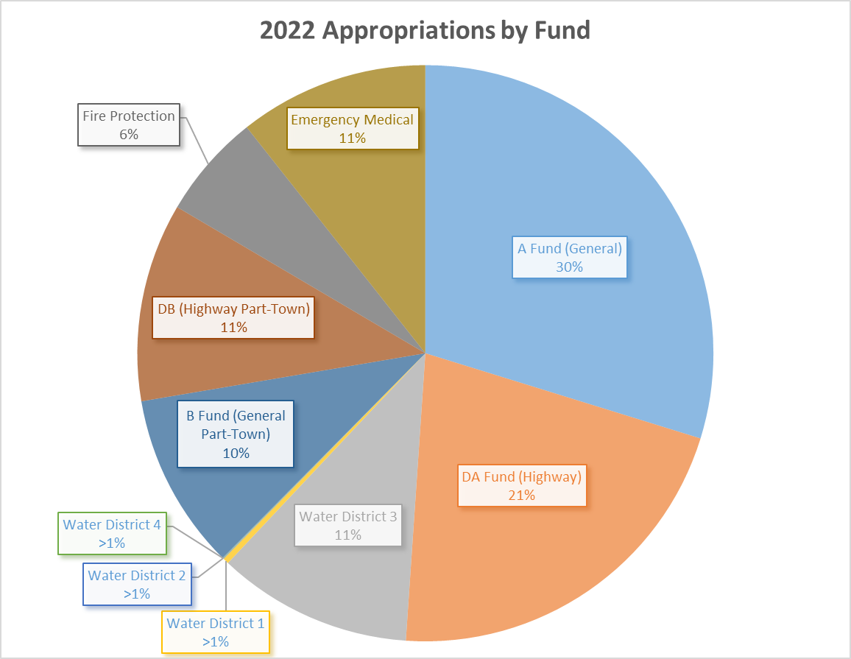
Total = $3,899,292

Fund | Fund expenses | Who pays for it through the tax levy
A “General fund” | Town Board, Town Hall and Town Court staff salaries, Highway Superintendent salary, benefits, facilities costs, Town Hall utilities, communication and mailing costs, youth, community, and environmental services, attorney costs | Town and village residents
B | Building code officer salary, Zoning/Planning officer salary, benefits as applicable, flood and erosion control administrative costs | Funded primarily by sales tax. No property tax is used.
DA | Machinery costs, bridge maintenance, brush and weed control, snow removal, highway staff salaries and benefits | Town and village residents
DB | Highway maintenance, highway staff salaries and benefits | Funded primarily by sales tax. No property tax is used.
Water | Water purchases, administrative costs, infrastructure and maintenance costs SW3 = Water District 3 | Those in the water district
Fire/ EMS | Fire (SF) and EMS (SM) services | Town residents, outside the Village
Other | Lighting | Town and village residents

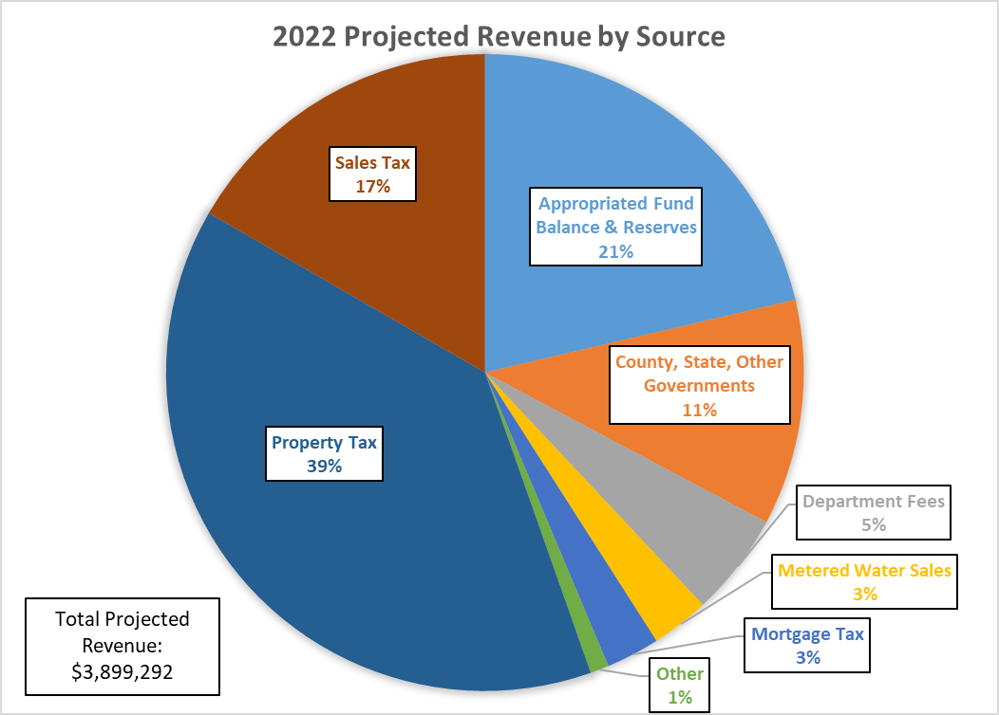

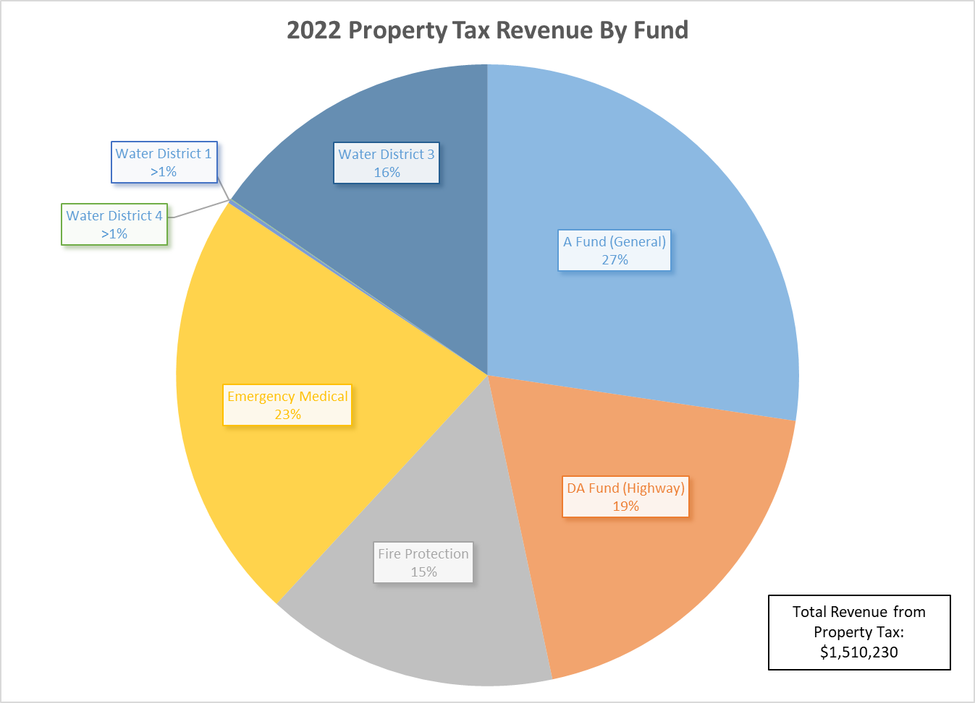
Note: property tax is not levied in the B or DB funds
2022 BUDGET HIGHLIGHTS

- The 2022 Town of Ulysses total spending increases by 17% over the 2021 modified budget. The budget includes $37,201 in new taxes and $142,684 or 28% more in projected sales tax revenues based on increased collections and a new model for projecting this revenue based on an analysis of historical trends.
- $95,350 or 30% of federal ARPA funding is used to offset a mix of town wide studies and water infrastructure.

- In addition to the expenses and revenues to maintain current services, this budget invests $220,000 in reserves for targeted future spending, using primarily the savings in our fund balances.

INCREASES TO SUPPORT TOWN PRIORITIES:

- High Quality Roads and Ditch Maintenance: The Highway Department needs three new pieces of equipment:
  - A new pick-up truck capable of plowing is on order using funds raised in 2021 but will be paid for in 2022 with fund balance due to supply chain delays.
  - A new 10-Wheeler truck needed to replace an aging vehicle will be financed over 3 years.
  - A multi-use excavator and trailer will be purchased in 2022 using a mix of Reserve funds, appropriated fund balance, and tax levy.

- Investing in our Employees who Serve the Public:
  - Town employees represent our most important asset and the 2022 budget includes raises of 4% to recognize the very low increase in 2021 due to COVID and increasing inflation. The same health care coverage will cost 5% more in 2022.
  - The Town is finalizing negotiations with the highway employees affiliated with the Teamsters Union and their hourly rate will be increasing more than 4% to better align their wage scale with other municipalities.
  - Providing part-time support staff for the Planner and Supervisor.
  - Long-term disability insurance offering an Employee Assistance Program is added in 2022.

- Increasing Enforcement of our Codes and Regulations
  - The Building and Zoning Code Enforcement Officer position is being increased from 27 to 35 hrs/week.
  - Spending for attorneys to help with enforcement litigation increased in 2021 has been maintained.

- Modernization of Information Technology
  - 3 computers will be upgraded more affordably with refurbished equipment due to supply chain issues.
  - An analysis of our current information technology management and policies will be conducted to assess the costs of modernizing and becoming fully compliant with recommendations from the NYS Comptroller.
  - Upgrading of software to improve efficiency for water billing, building and zoning permits is planned.

- Planning for the Future 2022 will be a year of transition with a new Supervisor and a new Planner and a very ambitious work plan, including new initiatives on top of on-going services:
  - Water studies to assess volume, quality, and potential risks of more frequent stormwater events;
  - Surveys of residents and agricultural landowners to begin an update of the 2009 Comprehensive Plan;
  - Planning for community engagement to re-evaluate our current goals and guide plans for the future
  - Developing a plan for 70% of the $320,639 1-time funds from American Rescue Plan Act (ARPA);
  - Adoption and implementation of new town policies on noise, animal protection, and special permits;
  - Possible action on the potential annexation of town parcels property into the Village;
  - Expansion and creation of water districts to address water quality and access issues;
  - Analysis of Town finances and updating of policies on fund balances, reserves, and capital planning.

- Support for Recreation and Community Services
  - The Town assumed responsibility for the joint Town-Village recreation program in 2020. Due to COVID, most programs were delayed until 2021 and we hope conditions will allow for expanded programming during 2022.The 20hr/week year-round Director will flex hours seasonally.
  - The Town has maintained its contracts for current community services and added support for the Trumansburg Farmers Market starting in 2022.
In conclusion, the tax levy presented in the 2022 Preliminary Budget includes a proposed increase of 2.53% that we believe meets our residents’ needs affordably while making value-added improvements, planning for future expenses and, maintaining sufficient savings for uncertainties or emergencies that may affect the Town. I am grateful to Michelle E. Wright for her thoughtful, thorough, and well-organized budget development process. I also want to sincerely thank all of our staff for working creatively and collaboratively on this budget and throughout the year and during COVID to provide excellent service our residents. The Town Board members’ careful review of all spending and projected revenues can reassure our residents that we are careful stewards of the tax dollars needed to provide the quality of services our community expects and deserves.

Respectfully submitted, Nancy Zahler

TIME TREND DATA FOR TOWN OF ULYSSES

