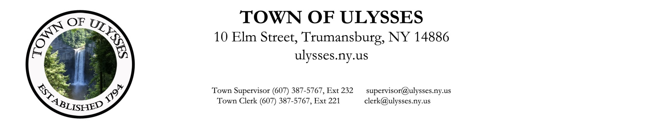

Activity Report
Town of Ulysses Fire Inspector
Lucas Albertsman
October 2020

Fire Inspections 6
Invoices sent out 5
Notices sent 2
Operating permits issued 7

